SIMATS ENGINEERING

ASSESSMENT TOOL 2: Concept Mapping

COURSE NAME: COMPUTER VISION COURSE CODE: ITA05

COURSE OUTCOME COVERED

CO1: Apply the fundamental concepts, image formation models, and processing techniques for analyzing Computer Vision systems. (BTL 3)

Assessment Tool Weightage: 20%

QUESTIONS: 4 Total Marks:50

Annexure A CONCEPT MAPPING

Code of Conduct:

I M. Phanith Chandu (192425238) (Name / Reg No) certify that this submission is my original work and that I have adhered to the guidelines specified for this assessment.
I understand that any violation of academic integrity rules will result in disciplinary action.

Signature of the student: M. Phanith Chandu

Q.  No | Concept Identification (25%) | Linkages  (25%) | Organizatio n (20%) | Integratio n of Literature (20%) | Clarity  (10%) | Total Score (100%)
1
2
3
4
Total

Annexure A CONCEPT MAPPING
- Construct a comprehensive and well-organized concept map that accurately identifies all key concepts from literature involved in the pipeline from real-world scene capture to digital image representation, establishes clear and meaningful relationships among intermediate transformations and dependencies, integrates insights from multiple studies, and presents the information in a clear and visually structured manner.

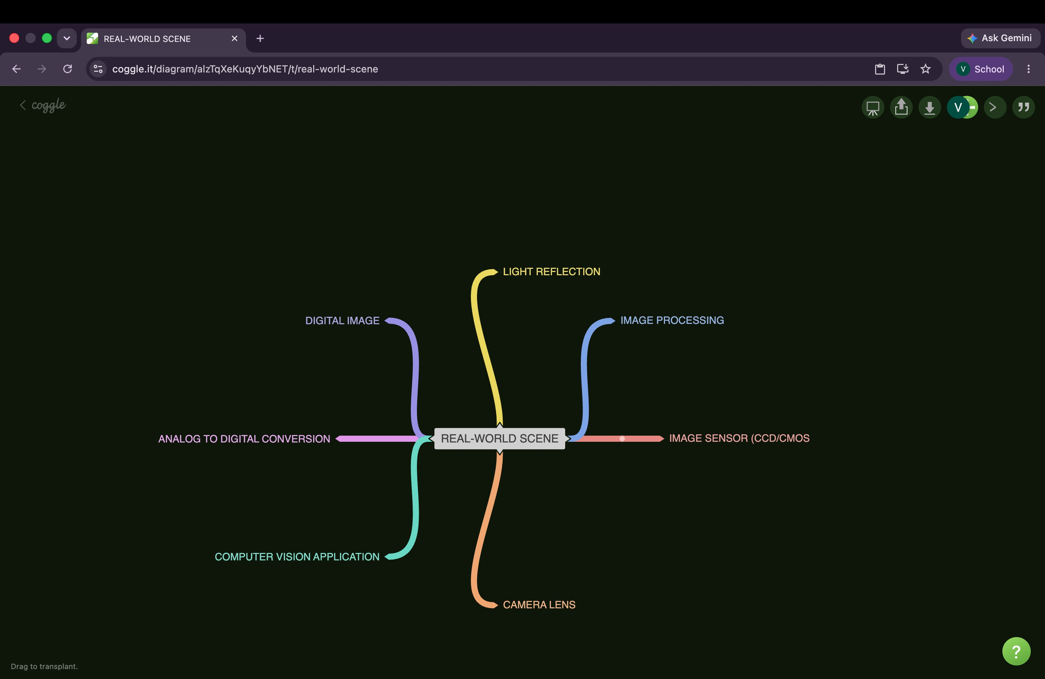

- Develop a hierarchically structured concept map that identifies major stages of visual data handling in a Computer Vision system, clearly illustrates logical relationships and contributions of each stage toward generating meaningful outputs, incorporates relevant literature connections, and ensures clarity and readability.

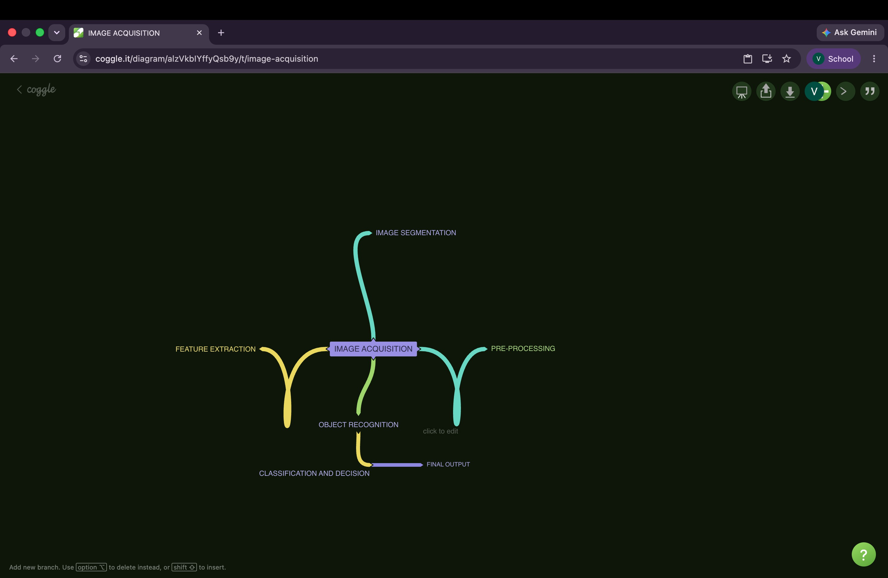

- Create a detailed concept map that accurately identifies concepts related to image resolution and intensity levels, establishes clear cause–effect relationships with image quality and usability, integrates supporting evidence from literature, and presents the concepts in a logically organized and visually clear format.

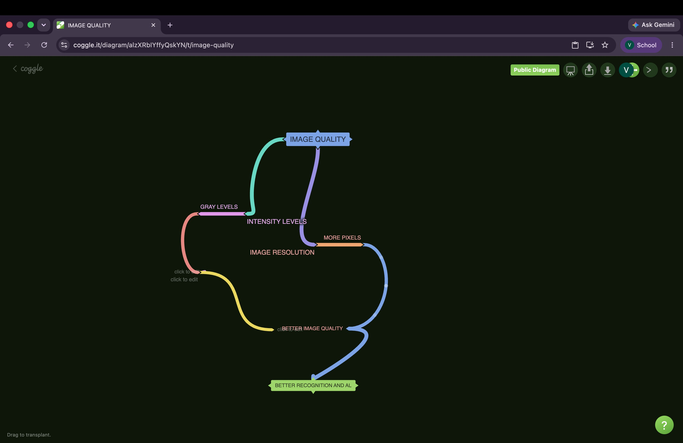

- Design an analytically organized concept map that identifies key factors in image acquisition conditions, clearly links them to downstream processing and application performance through meaningful relationships, integrates findings from relevant studies, and ensures a well-structured and easy-to-interpret presentation.

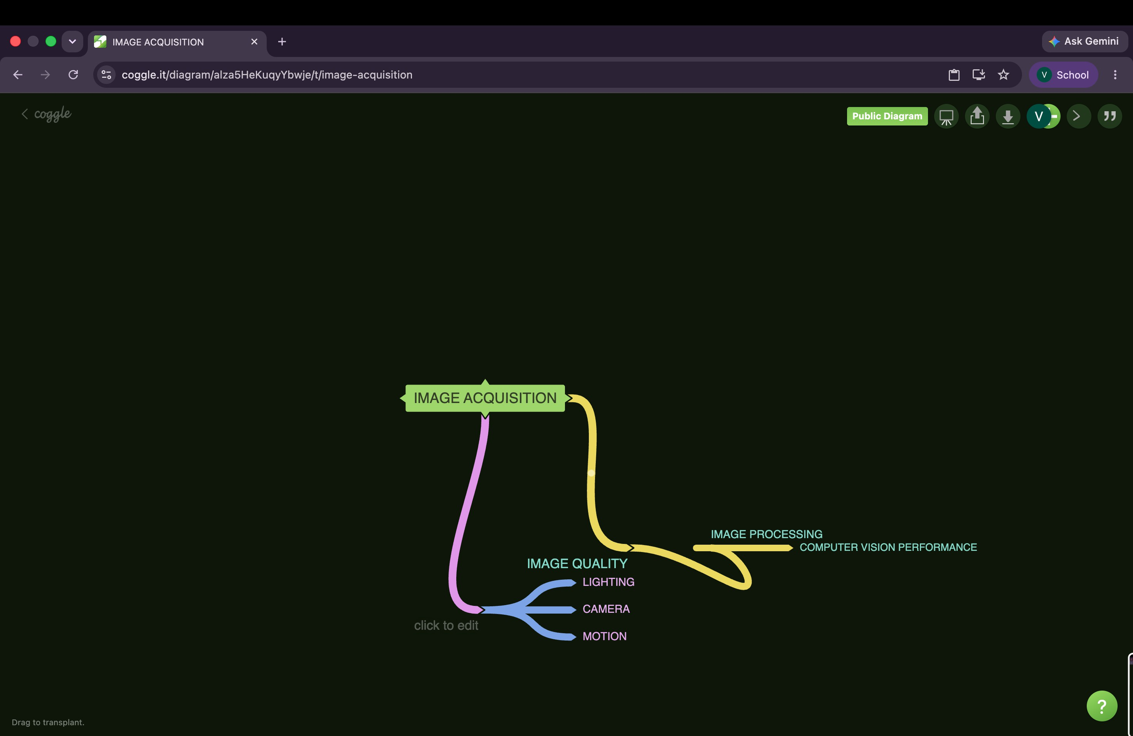

RUBRICS FOR CALCULATION:

Criteria | Weig htage | Level 4 (Exemplary) | Level 3 (Proficient) | Level 2 (Developing) | Level 1 (Beginning)
Concept Identificatio n | 25% | Identifies all key concepts from literature accurately and comprehensively | Identifies most key concepts with minor omissions | Identifies limited concepts; some are irrelevant or missing | Fails to identify essential concepts
Linkages | 25% | Establishes clear, meaningful, and accurate relationships between | Shows correct relationshi ps with minor gaps | Relationships are weak, unclear, or partially incorrect | No meaningful relationship s established
Organizatio n | 20% | Concepts are well-structured hierarchically with logical flow and grouping | Mostly organized with minor structural issues | Some organization but lacks clear hierarchy | No logical organization or structure
Integration of Literature | 20% | Integrates multiple studies effectively to show connections and | Shows some integration of literature | Limited integration; mostly isolated concepts | No integration of literature evidence
Clarity | 10% | Concept map is clear, neat, visually structured, and easy to interpret | Generally clear with minor readability issues | Clarity is reduced; difficult to interpret in parts | Poorly presented and hard to understand

